North Sydney & Hornsby Housing Affordability Report

Analysis period: 2022-Q1 to 2025-Q3

Executive summary
North Sydney & Hornsby is best understood as a high-cost but internally segmented housing market. By 2025-Q3, the region recorded a median sales price of about $1.82 million, median weekly rent of $844, a 12.9x Price-to-Income ratio, and 30.9% rent burden.
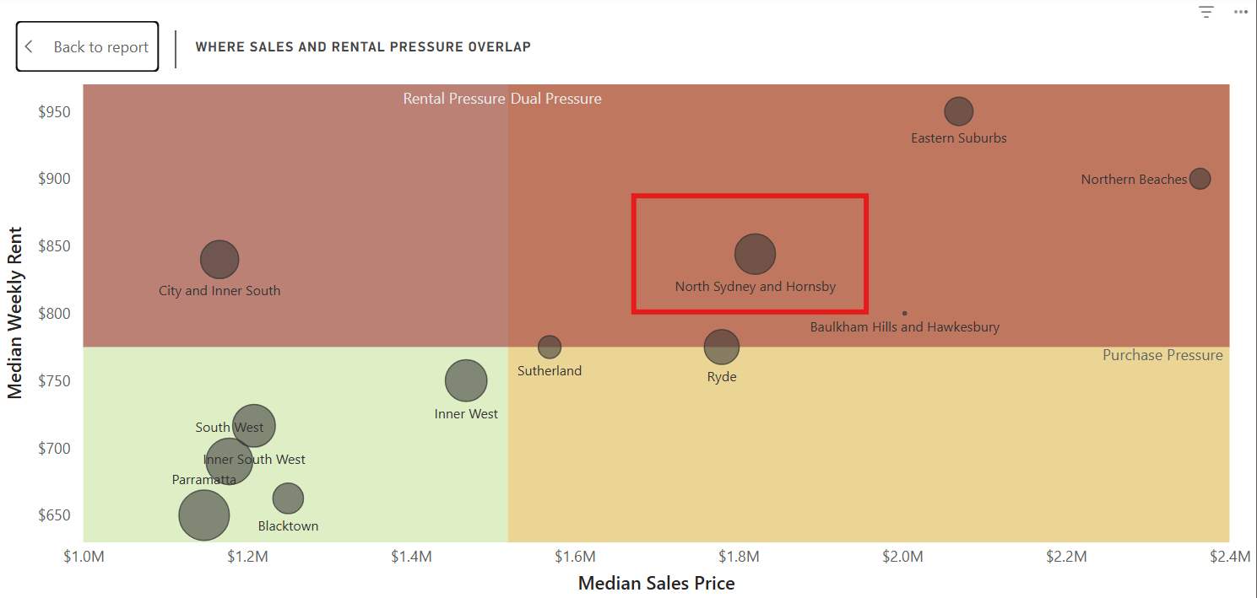
The region Consistently sits in the dual pressure region with both weekly rent and sales price above median mark
The main change since 2022 has not been a uniform escalation in purchase prices. Instead, rents have repriced much more consistently than sales prices, while purchase activity has remained resilient. Across a comparable Q3 postcode cohort, median rent growth was around 39%, versus only about 6% median sales-price growth. At the same time, sales transactions increased by roughly 22%.
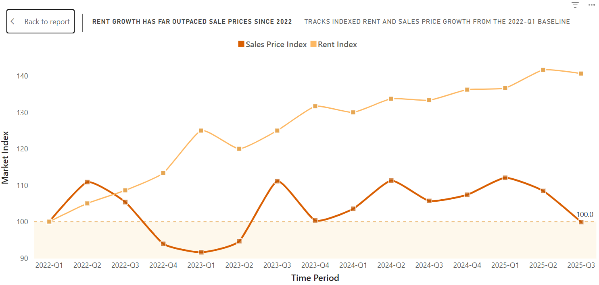
A comparison b/w rent and sales price growth: North Sydney and Hornsby
The result is a region where purchase affordability remains structurally poor, but the incremental affordability deterioration since 2022 has increasingly come from renting.

Market behaviour: stable rental base, lower turnover, stronger rents
The rental market did not materially shrink. For the same 15 suburbs observed across Q3 periods:
Rental-market indicator | 2022-Q3 | 2025-Q3 | Change
Overall rental bonds | 45,294 | 45,013 | -0.6%
New bonds | 4,657 | 3,868 | -16.9%
Weighted turnover | 10.28% | 8.59% | -1.69 pp

Therefore, the strongest interpretation is lower rental mobility/turnover rather than a shrinking rental base. There is some Q1–Q3 seasonality in turnover, but the Q3-to-Q3 comparison confirms that the longer-run reduction is not simply seasonal.
In contrast, purchase activity strengthened. Across comparable Q3 suburbs, total sales rose from roughly 1,499 to 1,827 (+22%). High purchase costs therefore did not prevent transaction activity from recovering.
This creates an important regional pattern:
The ownership market remained active, while rents rose strongly within a broadly stable rental-bond base but with fewer new leases relative to that base.
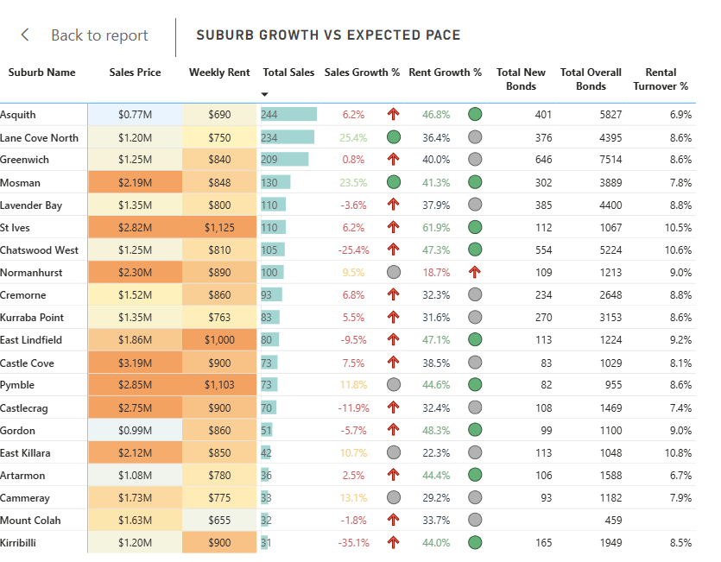
North Sydney Hornsby Suburb Patterns

Affordability shifted increasingly toward the rental side
Among comparable suburbs, median rent burden increased from roughly 23% in 2022-Q2 to 31% by 2025-Q3, while Rent-v-CPI moved from approximately +1% to +18%.
Price-to-Income ratios remained high but were much less uniformly directional. Some suburbs experienced rising prices, others stagnation, and others large movements caused partly by transaction/property mix.
This is reflected in the change in affordability classifications. In 2022, the sample was dominated by purchase-led or moderate-purchase-pressure markets. By 2025-Q3, the geography had shifted toward a mixture of rent-led, combined-pressure and persistent purchase-led markets.
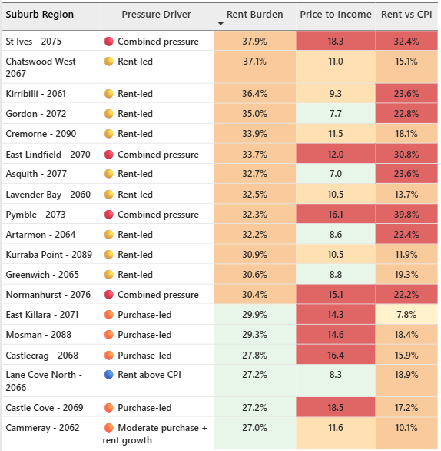
Pressure Drivers in different suburbs at 2025-Q3: North Sydney and Hornsby
The region therefore does not have one affordability problem. It contains several distinct regimes.

Spatial affordability structure
Market type | Key suburbs | 2025-Q3 profile | Interpretation
Lower North Shore rent-led / apartment belt | Artarmon, Greenwich, Kirribilli, Lavender Bay; Chatswood as proxy | P/I generally moderate; rents rising strongly | Large apartment/rental markets where rental deterioration has outpaced purchase pressure
Prestige purchase-led belt | Mosman, Castlecrag, Castle Cove, East Killara | Median P/I ~15.5x, burden ~28.6% | Property values remain extremely high even where recent price growth is modest
Upper North Shore combined-pressure belt | St Ives, Pymble, East Lindfield, Normanhurst | Median P/I ~15.6x, burden ~33%, Rent-v-CPI ~+31.6% | Buying was already expensive; rents subsequently deteriorated enough to create pressure in both tenures
Northern affordability release | Asquith | P/I 7.0x, burden 32.7%, Rent-v-CPI +23.6% | Purchase affordability improves sharply, but rental pressure remains
Transition market | Lane Cove North | P/I 8.3x, burden 27.2% | Relatively balanced bridge between apartment-oriented Lower North Shore and higher-pressure northern markets

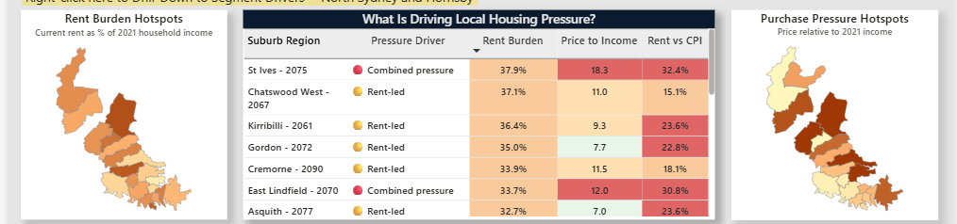
Dual maps showcasing rent and purchase pressure in different suburbs by 2025-Q3

Lower North Shore: rent-led rather than purchase-led
The Lower North Shore cluster is characterised by comparatively moderate purchase affordability but strong rental deterioration. By 2025-Q3, suburbs in this group generally had much lower P/I ratios than the prestige and combined-pressure clusters, while rents had risen sharply.
ABS data helps explain the structural difference: flats/apartments account for 86.8% of Kirribilli, 68.4% of Artarmon, 70.8% of Lane Cove North and 67.6% of Chatswood. (ABS – Kirribilli) This larger supply of smaller dwellings helps keep purchase prices relatively more accessible than in detached-house-dominated suburbs.
That aligns with your segment-level findings. Across North Sydney & Hornsby, most rental activity occurs in flats/units and 1–2BR dwellings, while these segments show lower severity than houses and 3+BR properties. So the Lower North Shore has a deep mainstream rental market, but that market has still experienced strong repricing.
Lane Cove North illustrates the softer end of the cluster: sales rose from 175 to 234, sales-price growth reached +25.4%, rent growth +36.4%, yet P/I remained only 8.3x.
Chatswood is more strongly rent-led: rent growth +47.3%, burden 37.1%, P/I 11.0x, with a large rental base of 5,224 bonds.
Overall, the apartment-heavy housing structure helps limit purchase pressure, but strong demand within a large rental market has still produced substantial rental affordability deterioration.

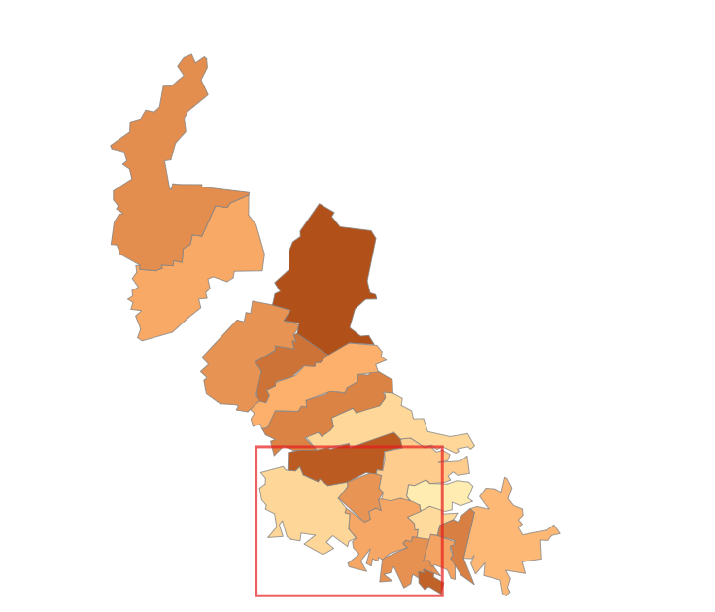
Lower North Shore Cluster
Prestige belt: structural purchase pressure
Suburbs: Mosman, Castlecrag, Castle Cove and East Killara.
Postal and affordability trends
This cluster is purchase-led because property values are extremely high relative to income, even though recent price growth has been moderate.
By 2025-Q3, the cluster's median property price was about $2.47 million, while cumulative sales-price growth since 2022-Q1 was only around 9%. The median Price-to-Income ratio was ~15.5x, compared with a rent burden of only ~28.6% and Rent-v-CPI of ~+16.6%.
This shows that the main affordability constraint is the absolute cost of buying, rather than a recent price boom.
Why is rent burden comparatively moderate?
High rents do exist, particularly for large houses, but this does not translate into equally severe suburb-wide rental burden.
Three factors help explain this:
- High household incomes reduce rent as a proportion of income.
- Castlecrag and Castle Cove have very small rental markets — only about 11% of dwellings were rented in 2021. (Landchecker castleCrag NSW)
- Mosman has a substantial apartment market, with around 52% of dwellings being flats/apartments, providing rental options below the cost of prestige detached houses.
So expensive individual house rents do not necessarily dominate the overall suburb rental measure.
Segment and external evidence
Regional segment analysis shows the strongest rental pressure in houses and 3–4+ bedroom dwellings. This aligns with the housing structure of Castlecrag, Castle Cove and East Killara:
Suburb | Separate houses | 4+ bedrooms
Castlecrag | 97.4% | 63.3%
Castle Cove | 90.3% | 65.7%
East Killara | 99.5% | 82.5%
(Australian Bureau of Statistics)
ABS Census data therefore confirms that these are predominantly large, low-density housing markets.
Their harbour/peninsula locations, limited land and established low-density character also constrain the supply of comparable premium housing, helping sustain very high property values.
Interpretation
The prestige cluster is purchase-led because scarce, large and premium housing keeps property values extremely high relative to income. Rental costs are also high, but high household incomes, small rental sectors in Castlecrag and Castle Cove, and Mosman's apartment stock keep aggregate rent burden comparatively moderate.
External references: ABS 2021 Census QuickStats; Mosman Council and Lower North Shore planning material.

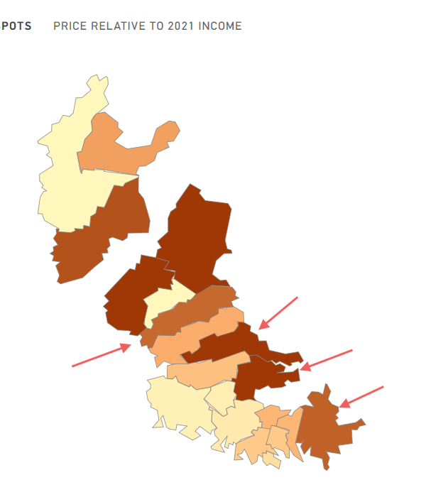
Prestige Belt Regions
Upper North Shore: Genuine combined pressure
St Ives, Pymble, East Lindfield and Normanhurst represent the strongest double squeeze.
Purchase affordability was already poor near the start of the analysis, with the cluster around 15–16x income. By 2025-Q3 that purchase pressure remained, but median rent burden had risen to about 33% and Rent-v-CPI to around +32%.
The housing mix provides a strong structural explanation. Pymble is around 80% separate houses, with about 60% 4+ bedroom dwellings, while approximately 86% of Normanhurst dwellings have three or more bedrooms. (Australian Bureau of Statistics)
This becomes especially important when combined with the segment analysis.
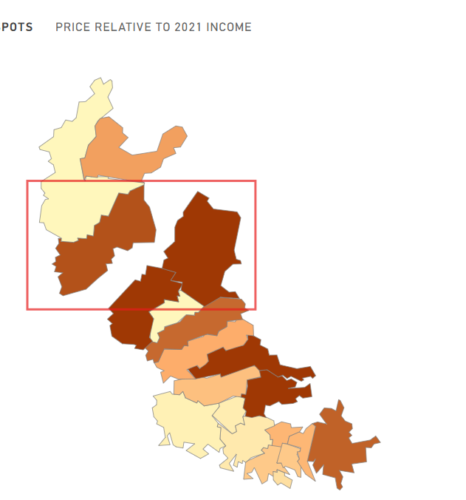
Combined Pressure Cluster

Segment drivers explain why the aggregate region appears less stressed
North Sydney & Hornsby had a high 2021 median weekly household income of roughly $2,729, which lowers the measured burden ratio despite high nominal rents.
But housing composition matters just as much.
2025-Q3 segment | Approx. rent | Rent vs CPI | Burden position | Market relevance
Flat/unit | ~$790 | +10.8% | Below overall | Dominates new bonds
House | ~$1,300 | +84.4% | ~+17 pp | Smaller but meaningful
1BR | ~$660 | -7.5% | ~-9 pp | High activity
2BR | ~$840 | +17.8% | ~-2 pp | Largest activity segment
3BR | ~$1,250 | +74.8% | ~+13 pp | Meaningful activity
4+BR | ~$1,620 | +127.8% | ~+27 pp | Low volume / concentrated

This produces a two-speed rental market.
Most rental transactions occur in flats/units and 1–2BR housing, where pressure is comparatively contained. The most severe affordability deterioration is concentrated in houses and 3–4+ bedroom housing.
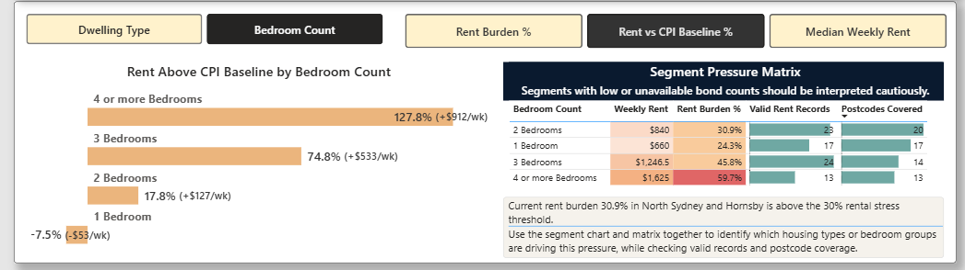
Bedroom Count Statistics by 2025-Q3

That explains two otherwise conflicting observations:
North Sydney & Hornsby can have some of Sydney's highest nominal rents while maintaining a comparatively moderate regional rent-burden ratio, yet still contain extremely stressed family-sized rental segments.
It also explains why the combined-pressure Upper North Shore is analytically important: its housing stock is concentrated precisely in the larger housing categories where the regional segment analysis finds the strongest rental stress.
Broader Sydney evidence reinforces this. Committee for Sydney/BDO reports that between 2011 and 2021 the stock of 3-bedroom dwellings increased only 3%, versus 50% for 1BR and 27% for 2BR dwellings, and that family-sized apartments exceeded its affordability threshold in more than 116 Sydney postcodes by 2025. (Committee for Sydney)

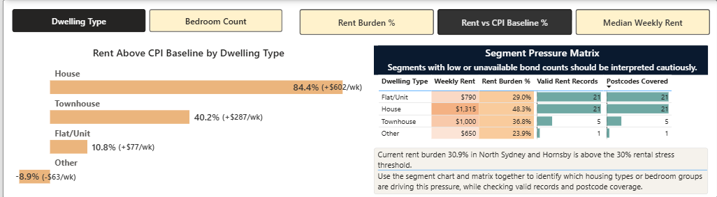
Dwelling type statistics by 2025-Q3

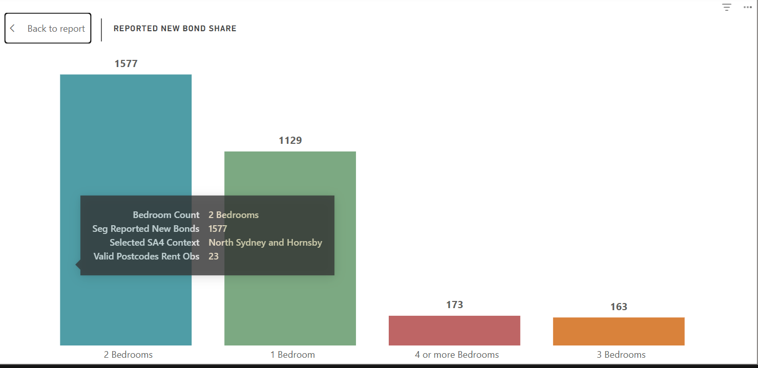
Reported Rental Bond Share by Bedroom count by 2025-Q3: North Sydney and Hornsby

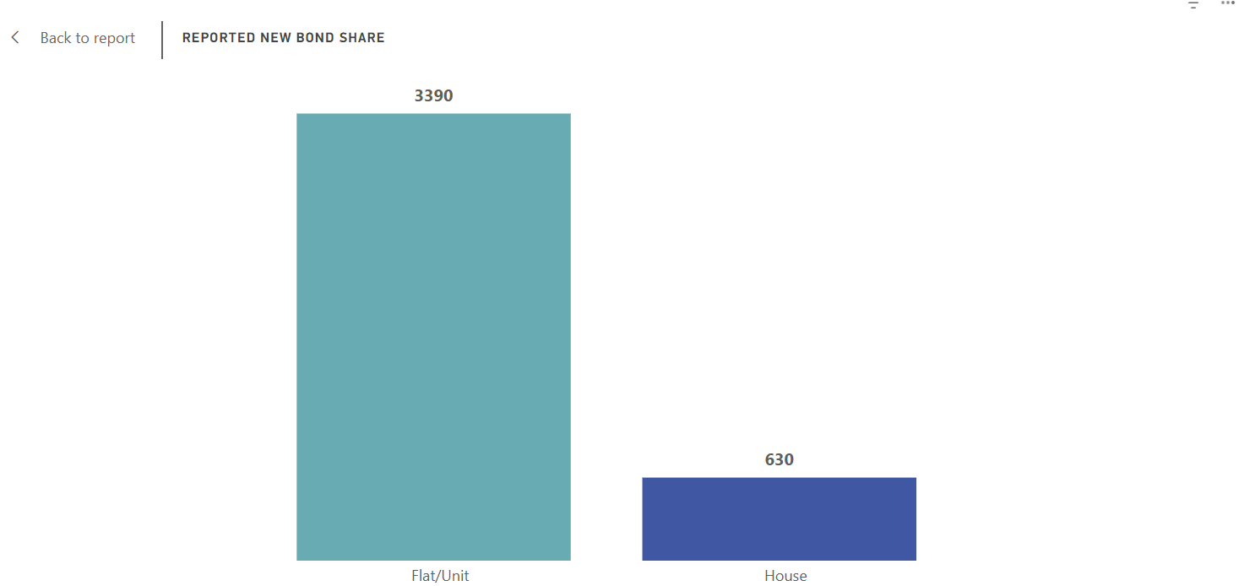
Reported Rental Bond Share by Dwelling Types by 2025-Q3: North Sydney and Hornsby

Asquith breaks the northward pattern
Asquith is the clearest purchase-affordability release valve.
By 2025-Q3:
Sales price: ~$770k
P/I: 7.0x
Rent burden: 32.7%
Rent growth: +46.8%
Sales-price growth: +6.2%
Sales: 244
Overall bonds: 5,827
Rental turnover: 6.9%.
Its housing structure differs materially from many nearby Upper North Shore suburbs. ABS data show 48.4% of Asquith dwellings are apartments, compared with 21.7% across NSW. (Australian Bureau of Statistics)

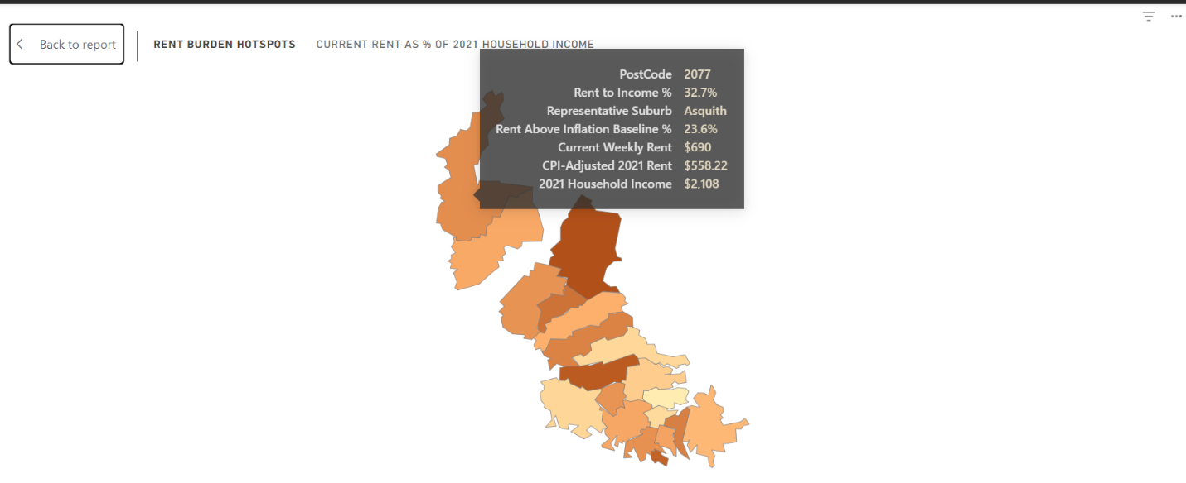

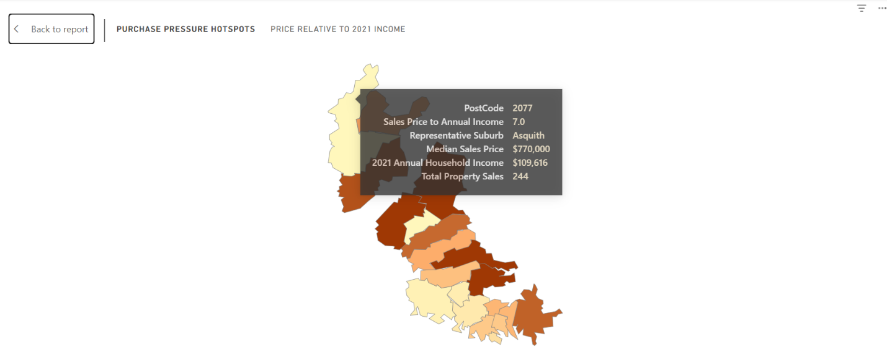

That difference is supported by planning policy rather than being accidental. Hornsby Council's earlier housing strategy rezoned parts of Asquith for townhouse and five- to ten-storey residential development, while its later Housing Strategy identifies Asquith as one of the locations where future household growth is expected to occur in predominantly high-density housing. It also reports that 69% of apartments constructed in newer medium/high-density areas were two-bedroom apartments. (Hornsby Shire Council)
Asquith therefore demonstrates an important point:
Additional apartment and smaller-dwelling capacity can materially improve purchase affordability without necessarily preventing rental pressure.

External evidence and planning context
Evidence | Relevance
ABS 2021 Census — North Sydney & Hornsby: 46% of occupied dwellings were apartments; the region simultaneously contains substantial 2BR and 4+BR stock. (Australian Bureau of Statistics) | Confirms that the SA4 is structurally heterogeneous rather than one uniform housing market.
ABS suburb QuickStats for Artarmon, Lane Cove North, Kirribilli and Chatswood. (Australian Bureau of Statistics) | Supports the apartment-oriented Lower North Shore interpretation.
Willoughby Housing Position Statement identifies Artarmon Station as the suburb's focal point and notes most of the suburb lies within 800m of it, with strong public-transport accessibility. (Willoughby City Council) | Supports the transport-accessible apartment-belt interpretation without claiming transport caused rent growth.
ABS Castlecrag, Castle Cove and East Killara. (Australian Bureau of Statistics) | Supports the low-density, large-home character of the purchase-led prestige cluster.
Hornsby Shire Housing Strategy. (Hornsby Shire Council) | Provides planning evidence for Asquith's higher-density housing role.
Committee for Sydney / BDO, State of the City 2026. (Committee for Sydney) | Provides wider evidence of constrained growth and worsening affordability in family-sized housing.

Overall conclusion
North Sydney & Hornsby is not a single affordability story but a set of distinct housing regimes shaped by geography, dwelling type and tenure. Purchase affordability remains structurally weak across much of the region, with very high Price-to-Income ratios in prestige and Upper North Shore markets, yet sales activity has remained resilient. Since 2022, the stronger deterioration has occurred on the rental side: rents have risen far faster than sales prices, while the rental-bond base has remained broadly stable and rental turnover has fallen.
This pressure is unevenly distributed. Apartment-oriented areas such as the Lower North Shore and Asquith retain comparatively better purchase affordability, although renters still face substantial rent growth. In contrast, St Ives, Pymble, East Lindfield and Normanhurst experience combined pressure, where already-high purchase costs are reinforced by worsening rents.
Segment analysis explains much of this difference: rental activity is concentrated in flats and 1–2BR dwellings, while the most severe pressure occurs in houses and 3+BR housing. High regional incomes moderate aggregate rent burden, but do not remove these underlying pressures. Overall, affordability depends less on the region as a whole than on where households live, what housing they need, and whether they rent or buy.
The strongest overall finding is therefore not that “North Sydney & Hornsby is unaffordable”, but that the form of unaffordability changes sharply across geography and housing type.

Method note: Rent burden and Price-to-Income use fixed 2021 Census household income, so they are best interpreted as comparative affordability indicators rather than exact 2025 household stress. The 2021 Census was also collected during pandemic-era international border restrictions, so its household composition may not fully represent the post-2022 renter population. Rent-v-CPI is therefore the stronger measure for analysing temporal deterioration.

